MIT WORLD PEACE UNIVERSITY 

Loan Approval Prediction Using Machine Learning

SUBJECT:

Machine Learning

SUBMITTED BY
Shraddha G. Sonawane
M.Sc. Statistics

INSTITUTION
MIT World Peace University

ACADEMIC YEAR
2025 – 2026

INDEX

Sr. No. | Contents | Page No.
1 | Introduction
2 | Problem Statement & Objectives
3 | Dataset & Cleaning Process
4 | Methodology & Model Building
5 | Interpretations & Conclusions
6 | Future Scope

Introduction

Machine Learning has become an essential technology in the banking and financial sector for making accurate and data-driven decisions. One of the major challenges faced by banks is identifying whether a loan applicant is eligible for a loan. Traditional loan approval processes require significant manual effort, are time-consuming, and may lead to human errors.
This project focuses on developing a Loan Approval Prediction system using Machine Learning algorithms. The model analyses applicant information such as income, education, loan amount, credit history, employment status, and property area to predict whether a loan application should be approved.
Different classification algorithms were implemented and compared to identify the best-performing model. The project demonstrates how machine learning can improve the speed, accuracy, and reliability of loan approval decisions.

Problem Statement
Financial institutions receive a large number of loan applications every day. Evaluating every application manually is time-consuming and may result in inconsistent decisions. There is a need for an automated system that can predict loan approval based on applicant information.

Objectives
- Develop a machine learning model for loan approval prediction.
- Perform data pre-processing and cleaning.
- Handle missing values effectively.
- Convert categorical variables into numerical values.
- Train multiple classification models.
- Compare model performance.
- Select the best-performing model.
- Evaluate model performance using different evaluation metrics.

Data Cleaning
The dataset was cleaned and pre-processed before building the machine learning models to ensure data quality and improve prediction accuracy.

Dataset Description – Loan Prediction

Variable Type | Variables
Numerical | Age, Person Income, Employee Experience, Loan Amount, Loan Interest Rate, Loan Percentage, Credit History, Credit Score
Categorical | Gender, Education, Home Ownership, Loan Intent, Previous Loan
Target Variable | Loan Status

Data Understanding and Preliminary Analysis

1. Head and Tail
- Head: Displays the first five rows of the dataset to understand its structure.
- Tail: Displays the last five rows to inspect the final observations.

2. Descriptive Statistics (describe())
- Summarises numerical variables using count, mean, standard deviation, minimum, maximum, and quartiles.
- Helps understand the distribution and range of the dataset variables.

3. Missing Values
- No missing values were found in the dataset.
- Therefore, missing-value imputation was not required.

4. Duplicate Values
- No duplicate rows were found.
- All observations were retained for further analysis.

Loan Status Distribution

Loan Status | Count | Percentage
0 | 35,000 | 77.78%
1 | 10,000 | 22.22%
Total | 45,000 | 100%
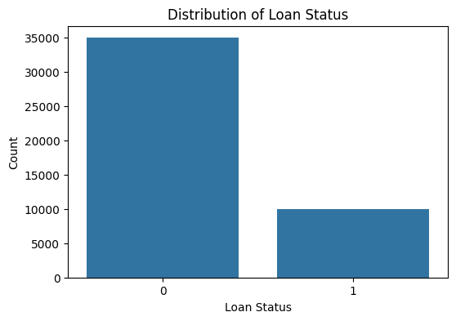
- Correlation Analysis

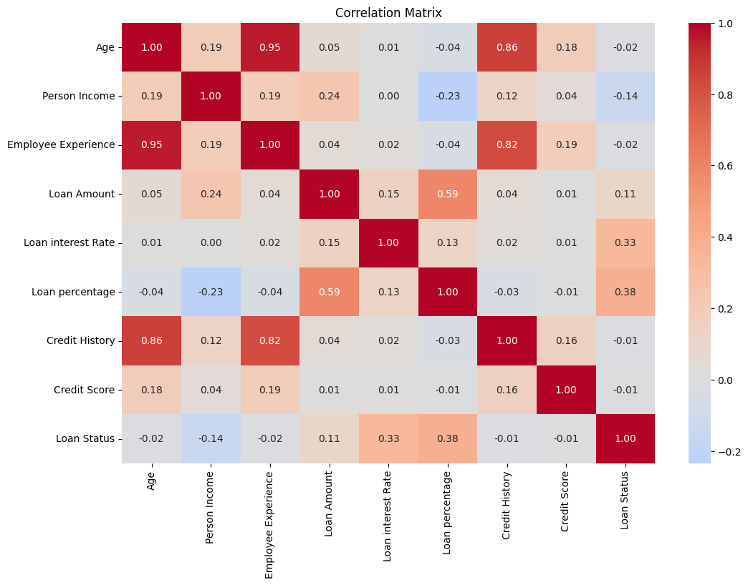
The heatmap shows a strong correlation between Age and Employee Experience (0.95). Loan Status is moderately correlated with Loan Percentage (0.38) and Loan Interest Rate (0.33). These relationships help identify potential multicollinearity and understand feature associations.

Encoding of Variables
Objective: To convert categorical variables into numerical values so that machine learning algorithms can process them.

Method used: Label Encoding
Label Encoding assigns a unique numerical value to each category.

Target Variable Distribution Analysis
Objective: To examine the distribution of the target variable (Loan Status) and identify whether the dataset is balanced or imbalanced.

Distribution of the target variable

Dataset | Class 0 | Class 1 | Total
Original dataset | 35,000 (77.78%) | 10,000 (22.22%) | 45,000
Training dataset | 28,000 (77.78%) | 8,000 (22.22%) | 36,000
Testing dataset | 7,000 (77.78%) | 2,000 (22.22%) | 9,000

Interpretation
- The original dataset contains 45,000 observations.
- Class 0 represents 77.78% of the observations, while Class 1 represents 22.22%.
- The target variable is imbalanced, because Class 0 occurs much more frequently than Class 1.
- An 80:20 train-test split preserved the same class proportions in both datasets.
- This imbalance may cause a model to favour the majority class and perform poorly when identifying the minority class.

Percentage Distribution of Target Variable
Objective: To verify whether the proportion of each target class remains consistent in the training and testing datasets after splitting.

Loan Status | Training Percentage | Testing Percentage
Class 0 | 77.78% | 77.78%
Class 1 | 22.22% | 22.22%

Interpretation
- Both training and testing datasets have identical target class proportions.
- Class 0 accounts for 77.78% of observations, while Class 1 accounts for 22.22%.
- This indicates that the original class distribution was preserved during the train-test split.
- Maintaining similar proportions helps ensure that model evaluation is representative of the original dataset.
- However, the target remains imbalanced, so additional techniques such as SMOTE or class weighting may be required.

SMOTE Analysis (Before and After Balancing)
Objective: To handle class imbalance in the training dataset using SMOTE (Synthetic Minority Over-sampling Technique).
Before SMOTE: The training dataset contained 36,000 observations and 10 independent variables. Class 0 had 28,000 observations (77.78%), while Class 1 had 8,000 observations (22.22%).
- Application of SMOTE: SMOTE generated synthetic observations for the minority class to balance the training dataset.
- After SMOTE: The training dataset increased to 56,000 observations, with 28,000 observations in Class 0 and 28,000 in Class 1. Both classes represented 50% of the training data.
- Testing Dataset: The testing dataset remained unchanged, containing 9,000 observations and 10 independent variables, with the original class distribution preserved.
Model Training: The three machine learning models were trained using the SMOTE-balanced training dataset containing 56,000 observations and 10 independent variables.
- Model Evaluation: The models were evaluated on the original testing dataset containing 9,000 observations. Training accuracy, testing accuracy, and overfitting gap were calculated.

Model performance comparison

Model | Training Accuracy | Testing Accuracy | Overfitting Gap
Logistic Regression | 77.55% | 77.38% | 0.18%
Decision Tree | 81.84% | 86.22% | −4.38%
SVM | 83.24% | 82.38% | 0.87%

Interpretation
- Logistic Regression: Achieved 77.55% training accuracy and 77.38% testing accuracy. The small gap indicates consistent performance on training and testing data.
- Decision Tree: Achieved the highest testing accuracy of 86.22%. Its testing accuracy exceeded its training accuracy by 4.38 percentage points, which does not indicate conventional overfitting.
- SVM: Achieved 83.24% training accuracy and 82.38% testing accuracy. The small gap indicates relatively consistent performance.

Model Building Using Class Weighting
- Objective: To address class imbalance by assigning higher weights to the minority class during model training.
- Methodology: Class weighting was applied to Logistic Regression, Decision Tree, and SVM models to reduce the impact of class imbalance without generating synthetic observations.

Model Performance Comparison

Model | Training Accuracy | Testing Accuracy | Overfitting Gap
Weighted Logistic Regression | 76.68% | 77.16% | −0.48%
Weighted Decision Tree | 87.85% | 87.34% | 0.50%
Weighted SVM | 83.53% | 83.38% | 0.16%

Interpretation
- Weighted Logistic Regression: Achieved 77.16% testing accuracy. Its small negative gap indicates that testing accuracy was slightly higher than training accuracy.
- Weighted Decision Tree: Achieved the highest testing accuracy of 87.34%, with a small overfitting gap of 0.50 percentage points. It demonstrated the strongest accuracy among the three weighted models.
- Weighted SVM: Achieved 83.38% testing accuracy, with a small gap of 0.16 percentage points, indicating consistent performance across training and testing datasets.

Conclusion
The Weighted Decision Tree performed best based on testing accuracy, achieving 87.34%, followed by Weighted SVM at 83.38% and Weighted Logistic Regression at 77.16%. The small training-testing accuracy gaps suggest that none of the models shows conventional overfitting based on accuracy alone.
Class weighting provides an alternative to SMOTE for handling imbalanced data. The final model should be selected after comparing precision, recall, F1-score, ROC-AUC, and confusion matrices, in addition to accuracy.

Model Performance Comparison
- Objective: To compare the performance of the weighted Logistic Regression, Decision Tree, and SVM models using accuracy, precision, recall, F1-score.

Performance comparison

Model | Accuracy | Precision | Recall | F1-Score | ROC-AUC
Weighted Logistic Regression | 77.16% | 49.11% | 77.10% | 60.00% | 84.64%
Weighted Decision Tree | 87.34% | 71.98% | 70.50% | 71.23% | 88.43%
Weighted SVM | 83.38% | 59.73% | 77.35% | 67.41% | 88.43%

Interpretation
- Weighted Logistic Regression: Achieved 77.16% accuracy and 77.10% recall. However, its precision of 49.11% indicates that a relatively large proportion of positive predictions were incorrect.
- Weighted Decision Tree: Achieved the highest accuracy (87.34%), precision (71.98%), and F1-score (71.23%). It provides the strongest overall balance of these metrics among the three models.
- Weighted SVM: Achieved the highest recall (77.35%), making it the strongest model for identifying actual positive cases based on recall. Its ROC-AUC of 88.43% was equal to that of the Decision Tree.
- ROC-AUC: The Decision Tree and SVM both achieved 88.43%, indicating comparable ability to distinguish between the two classes across classification thresholds.

Conclusion
The Weighted Decision Tree was selected as the best-performing model based on accuracy, precision, and F1-score. It achieved 87.34% accuracy and a 71.23% F1-score. However, if identifying as many minority-class cases as possible is the primary objective, the Weighted SVM may be preferable because it achieved the highest recall of 77.35%.

Future Scope
- Explore advanced models such as Random Forest and XG Boost.
- Improve performance through hyperparameter tuning and feature engineering.
- Apply advanced techniques to handle class imbalance.
- Use SHAP or LIME for model interpretability.
- Evaluate model fairness and test it on larger datasets.

